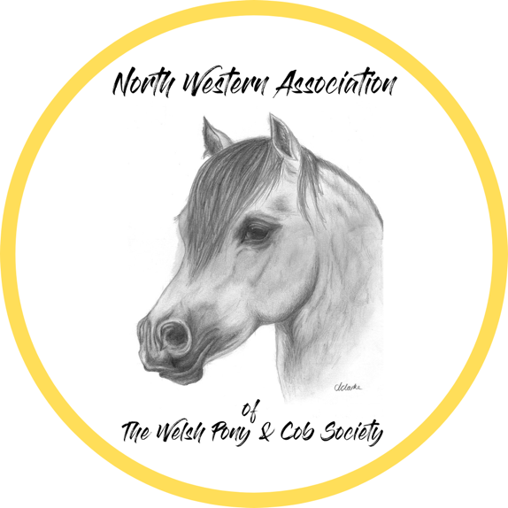

NORTH WESTERN ASSOCIATION OF WPCS WINTER SHOW

Reaseheath College
Nantwich
Cheshire
CW5 6DF

Date Sunday 1st November 2026

Affliated Welsh Pony & Cob Association Bronze Medal Show. Affiliation No AF000429

Welsh Pony & Cob Gelding Incentive Scheme – Overall Gelding Champion and Reserve, to be competed for by the highest placed geldings from each appropriate class within Sections A, B, C, D & PBW generously sponsored by the Sarum Investments Ltd.

Entries to

Mrs. Sarah Tattersall
36 New Lane
Croft
Warrington
WA3 7LW

07563410950

info@nwawpcs.co.uk

www.nwawpcs.co.uk

Online entries: https://nwawpcs.entrymaster.online

Judges

Welsh Section A – Mr C Cobley (Tryfel)
Welsh Section B & Part Bred – Mrs J Parry (Talponciau)
Welsh Section C – Miss T. M Baldwin (Janton)
Welsh Section D - Miss T. M Baldwin (Janton)
Young Handlers
Ridden - Mrs J Parry (Talponciau)

Many thanks to our kind sponsors, volunteers, stewards and our judges without whose help the show would not be here today

ENTRY FEES

ALL CLASSES £15 for Members & £20 for Non Members
Young Handlers - £7.50

On the Day Price £20 for Members & £25 Non Members

ENTRIES CLOSE – 28th October 2026

PLEASE MAKE ALL CHEQUES PAYABLE TO NWAWPCS or ENTER ONLINE at https://nwawpcs.entrymaster.online

It is your responsibility to be at the ring on time, please keep an eye on your classes once the ring has started

Ring A – Welsh Section B – 10am

Welsh Section B Championship

- Colt Foals
- Filly Foals
- Yearling colts
- Yearling Filly
- 2yr Old Colt
- 2yr Old Filly
- 3yr Old Colt
- 3yr Old Filly
- Gelding 3yrs & under

Highest placed foal eligible for the foal championship to be judged at the end of all classes
Highest placed Junior geldings eligible for Sarum Investments Championship to be judged at the end of all classes

Overall Welsh Section B Championship 1st & 2nd prizewinners to compete

Ring A - Part Bred Welsh – To Follow Section B’s NBT – 11:00am

Welsh Part Bred Championship

- Colt & Filly Foals
- Yearling Colt & Filly
- 2 & 3yr Old Colt & Filly
- Gelding 3yrs & under

Highest placed foal eligible for the foal championship to be judged at the end of all classes
Highest placed Junior geldings eligible for Sarum Investments Championship to be judged at the end of all classes

Overall Welsh Part Bred Championship - 1st & 2nd prizewinners to compete

RING A – Welsh Section A to follow Welsh Part Bred – NBT – 12pm

Welsh Section A Championship

- Colt Foals
- Filly Foals
- Yearling colts
- Yearling Filly
- 2yr Old Colt
- 2yr Old Filly
- 3yr Old Colt
- 3yr Old Filly
- Gelding 3yrs & under

Highest placed foal eligible for the foal championship to be judged at the end of all classes
Highest placed Junior geldings eligible for Sarum Investments Championship to be judged at the end of all classes

Overall Welsh Section A Championship - 1st & 2nd prizewinners to compete

RING B – Welsh Section C – 10:30am

Welsh Section C Championship

- Colt Foals
- Filly Foals
- Yearling colts
- Yearling Filly
- 2yr Old Colt
- 2yr Old Filly
- 3yr Old Colt
- 3yr Old Filly
- Gelding 3yrs & under

Highest placed foal eligible for the foal championship to be judged at the end of all classes
Highest placed Junior geldings eligible for Sarum Investments Championship to be judged at the end of all classes

Overall Welsh Section C Championship - 1st & 2nd prizewinners to compete,

RING B – Welsh Section D – to follow Welsh Section C’s – NBT – 11:30am

Welsh Section D Championship

- Colt Foals
- Filly Foals
- Yearling colts
- Yearling Filly
- 2yr Old Colt
- 2yr Old Filly
- 3yr Old Colt
- 3yr Old Filly
- Gelding 3yrs & under

Highest placed foal eligible for the foal championship to be judged at the end of all classes
Highest placed Junior geldings eligible for Sarum Investments Championship to be judged at the end of all classes

Overall Welsh Part Bred Championship - 1st & 2nd prizewinners to compete

RING B – Young Handlers to follow Section D’s NBT 12pm

Young Handler Championship Rosettes Kindly Sponsored By Newcroft Stud

- Tiny Tots Young Handler 4yrs – 8yrs, Mare or Gelding suitable for the handler
- Young Handler 9yrs – 12yrs, Mare or Gelding suitable for the handler
- Young Handler 13yrs – 16yrs, Mare or Gelding suitable for the handler
- Young Handler 17yrs – 21yrs, any pony suitable for the handler

Overall Young Handler Championship - 1st & 2nd prizewinners to compete

SUPREME INHAND CHAMPIONSHIPS

- Sarum Investments Junior Gelding Championship - Highest placed Junior geldings from eligible Welsh classes – Kindly Sponsored by Starlans Stud
- Foal Championship - All highest placed foals kindly sponsored by Croslyn Stud
- Members Championship – Highest place members from each class kindly sponsored by Hillview Equine & Supplies Ltd
- Supreme Inhand Championship - Champion & Reserve from all sections

Ridden Ring 1 (Full indoor) – NBT 1pm

- M&M Lead Rein
Open to mares or geldings 4yrs old and over not exceeding 121.9cm (12h). Riders must have attained their 3rd birthday but not their 9th birthday before 1st January in the current year. Ponies to be show in a suitable bridle. The lead rein must be attached to the noseband only.
- M&M First Ridden
Open to mares or geldings 4yrs old and over not exceeding 129cm (12.2). Riders must not have attained their 12th birthday before 1st January in the current year. Ponies are to be shown in a suitable bridle.

Mini Championship 1st & 2nd place in class 45 & 46 to compete in Championship
Highest place Wesh to max 4th place to receive the WPCS Performance Medal
- M&M Junior Ridden
Small Breeds (Not to have had 14th Birthday before Jan of this year) Large Breeds (Not to have had 18th Birthday before Jan of this year) – if entries permit will be split
Open to registered Mares or Gelding 4 years old & over
- Ridden Novice M&M (and Part breds)
Open to mares, geldings & stallions 4yrs old and over. Ponies to be show in a suitable bridle. Ponies must be registered in the main stud book of their studbook, Class with be split if sufficient entries.
- Ridden Open M&M (and Part breds)
Open to mares, geldings & stallions 4yrs old and over. Ponies to be show in a suitable bridle. Ponies must be registered in the main stud book of their studbook. Class with be split if sufficient entries

Ridden Championship 1st & 2nd place in classes 47 – 49 to compete in Championship
Highest place welsh to max of 4th place to receive the WPCS Performance Medal

Your Personal Data.
Exhibitor/s you will need to provide the WPCS with certain personal information relating to you. Your privacy is extremely important to WPCS, so we want you to know exactly how we will use that personal information. Our full privacy notice, setting out detailed information about matters such as what personal information we use, for what purpose we use it, what our legal basis for doing so is and who we share your personal information with, can be viewed on our website http://wpcs.uk.com/ If you prefer to see a hard copy of our privacy notice, please ask a member of WPCS staff to provide you with same.
Your details will be saved and maybe passed to the test and trace in the case of a confirmed covid19 case without our show.

SHOW RULES
- All entries in breed classes must be registered with their respective breed society or in the case of foals eligible.
- WPCS rules apply to all affiliated classes in hand.
- An exhibitor may not knowingly enter any animal bred, sold, owned, leased or produced by the judge or his immediate family or employer. See page 5 rulebook.
- Outside assistance will not be tolerated in any ring. Competitors ignoring this rule will be disqualified.
- Brood mares must be 4yrs & over.
- Foals must be at least 3 weeks old.
- Abusive behavior or bad language to any person, official or show assistant will not be tolerated.
- Any animal deemed to be a danger will be asked to leave the ring.
- Any objection must be made in writing within 30 minutes of the incident, with a £50 deposit, refundable if upheld.
- In the event of classes clashing it is up to the exhibitor to choose the class they wish to compete in.
- The judge’s decision is final.
- All exhibitors must have public liability insurance
- All dogs must be on leads at all times.
- No mucking out on the showground.
- Please make sure you adhere to the age limits with regard to HANDLING STALLIONS.
- All Animals must carry their passports and have current vaccinations in place (12monthly or first 2 vaccinations) Spot checks will be carried out, Foals are excempt
- It is your responsibility to make sure that you are at the ring in time for your class, once the ring ha started classes will follow on unless otherwise stated
- Please collect and take home your RUBBISH!

Sincere thanks to all our Sponsors, competitors, helpers, stewards, caterers our fantastic judges who give their time for our enjoyment.

We hope that you have enjoyed your day and will support us again in 2027.

For everyone who made this day happen THANK YOU!

